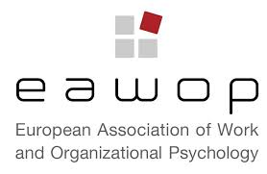

9th EAWOP WorkLab – Practitioner Skills Workshop
Working well remotely:
Impact, productivity and well-being
12th to 13th November, 2020, online
Note: Times are CET
Thursday 12th November
16.00 to 18:00  CET | Case studies of working well remotely and networking  - Organisers (Helen Baron, London, UK; Diana Rus, Amsterdam, The Netherlands Angela Carter, Exmouth, UK)  - Facilitated small group discussions about and exploration of participant case studies
18.00 to 19:00 CET | Optional online networking drinks

Friday 13th November
10.00 to 12.00 CET | Working and living for well-being  Interactive session led by Audrey McGibbon
12.30 to 14.00 CET | Informal online lunch
16.00 to 17.30 CET | Making remote meetings successful: Leveraging the surprising science of meetings  Interactive session led by Steven Rogelberg
17.30 to 18.00 CET | Review and Summary of learning/ Future WorkLab

Participants attending this WorkLab will benefit from:
- Appreciating the remote workplace from both research and practitioner perspectives
- Understanding what effects current changes are having on work-life balance, well-being and efficiency;
- Introduction to simple tools for maintaining and improving individual well-being
- Evidenced-based tips on how to make remote meetings successful
- Pooling expertise with other Work and Organizational Psychologists regarding working well remotely
- Gaining insight into the value of working with evidence-based methods.

